Fuzzy Controller for Inverted Pendulum

To demonstrate the principles of fuzzy logic, Pendulum, a fuzzy logic inverted pendulum simulator, was developed. Pendulum allows the user to experiment with fuzzy logic principles by setting up the rules and membership functions used to control the inverted pendulum. The user can then run the simulator and see how the system behaves by watching strip charts, a graphical display of the pendulum, profiles and the numerical values of important aspects of the system.

Pendulum Physiscs:

The pendulum will be simulated on a step by step basis. Each iteration of the simulator, a new value of angular position (e) and angular velocity (to) will be calculated. Using these values, the simulator will use fuzzy logic to determine the amount of current to supply to the motor. The simulator will then use this new value of current to determine the new torque output of the motor, and new angular position and velocity of the pendulum a finite (user definable) time later.

Equations involved:
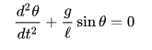
The differential equation which represents the motion of a simple pendulum is:
where g is acceleration due to gravity, l is the length of the pendulum, and

θ is the angular displacement.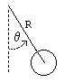

The pendulum is modeled as a point mass at the end of a massless rod. We define the following variables: θ = angle of pendulum (0=vertical), R = length of rod, T = tension in rod, m = mass of pendulum, g = gravitational constant
We will derive the equation of motion for the pendulum using the rotational analog of Newton's second law for motion about a fixed axis, which is τ = I α where τ = net torque, I = rotational inertia, α = θ''= angular acceleration
The rotational inertia about the pivot is I = m R2 . Torque can be calculated as the vector cross product of the position vector and the force. The magnitude of the torque due to gravity works out to be τ = −R m g sin θ . So we have: −R m g sin θ = m R2 α, which simplifies to
Θ'' = − g⁄R sin θ
This is the equation of motion for the pendulum.
Fuzzy rule base:
1) if the angle is zero and the ang. Velocity is zero then the current should be zero
2) if the angle is positive-small and the ang. Velocity is zero then the current should be negative-small.
3) if the angle is negative-small and the ang. Velocity is zero then the current should be positive-small.
4) if the angle is zero and the ang. Velocity is positive-small then the current should be negative-small.
5) if the angle is zero and the ang. Velocity is negative-small then the current should be positive-small.
6) if the angle is negative-small and the ang. Velocity is negative-small then the current should be positive-medium.
7) if the angle is positive-small and the ang. Velocity is positive-small then the current should be negative-medium.

Pendulum uses the table method of rule specification, and allows a maximum of nine linguistic terms (negative big, negative medium, negative small, negative zero, zero, positive zero, positive small, positive medium, and positive big). Rows of the table represent the angular position, while columns represent the angular velocity.
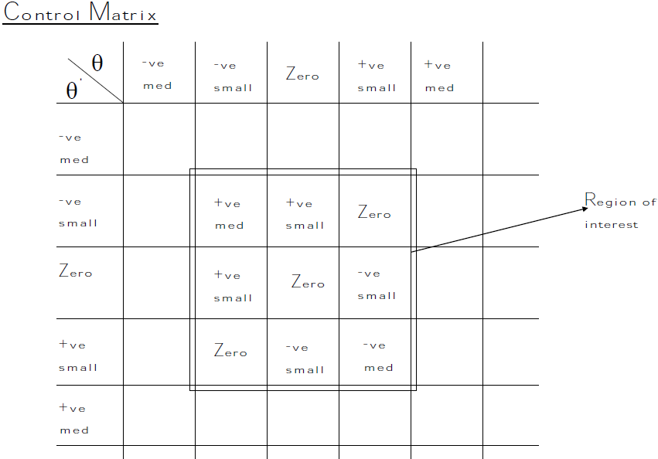

Results:

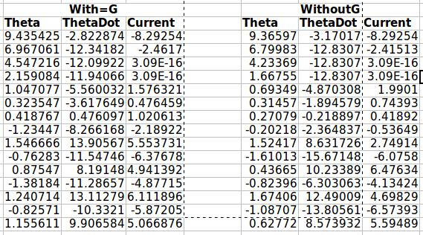
a) First-15 rows of output depicting the Theta, ThetaDot and Current values for the scenarios with g (gravity) and without g.

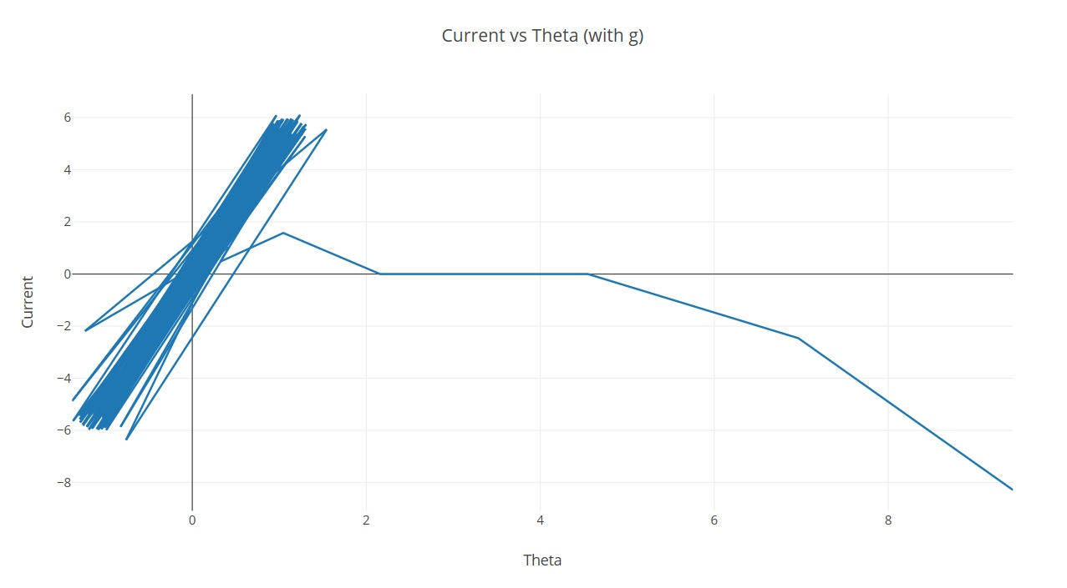
b) Graphs depicting the Theta, ThetaDot and Current values for the scenarios with g (gravity) and without g.

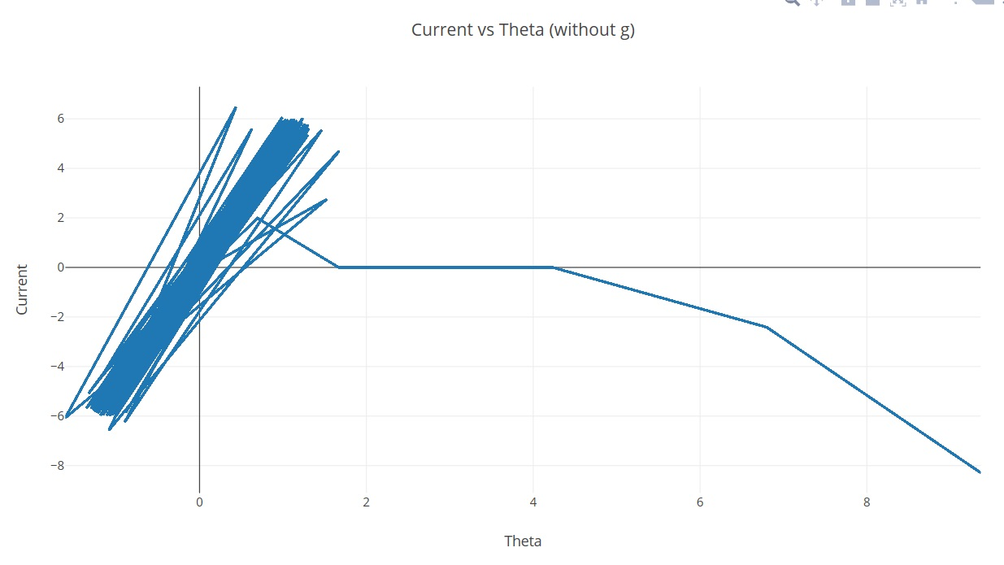

c) Profiles for Theta, ThetaDot and Current:
